CS 255 System Design Document - GRANT GIMER

UML Diagrams

UML Use Case Diagram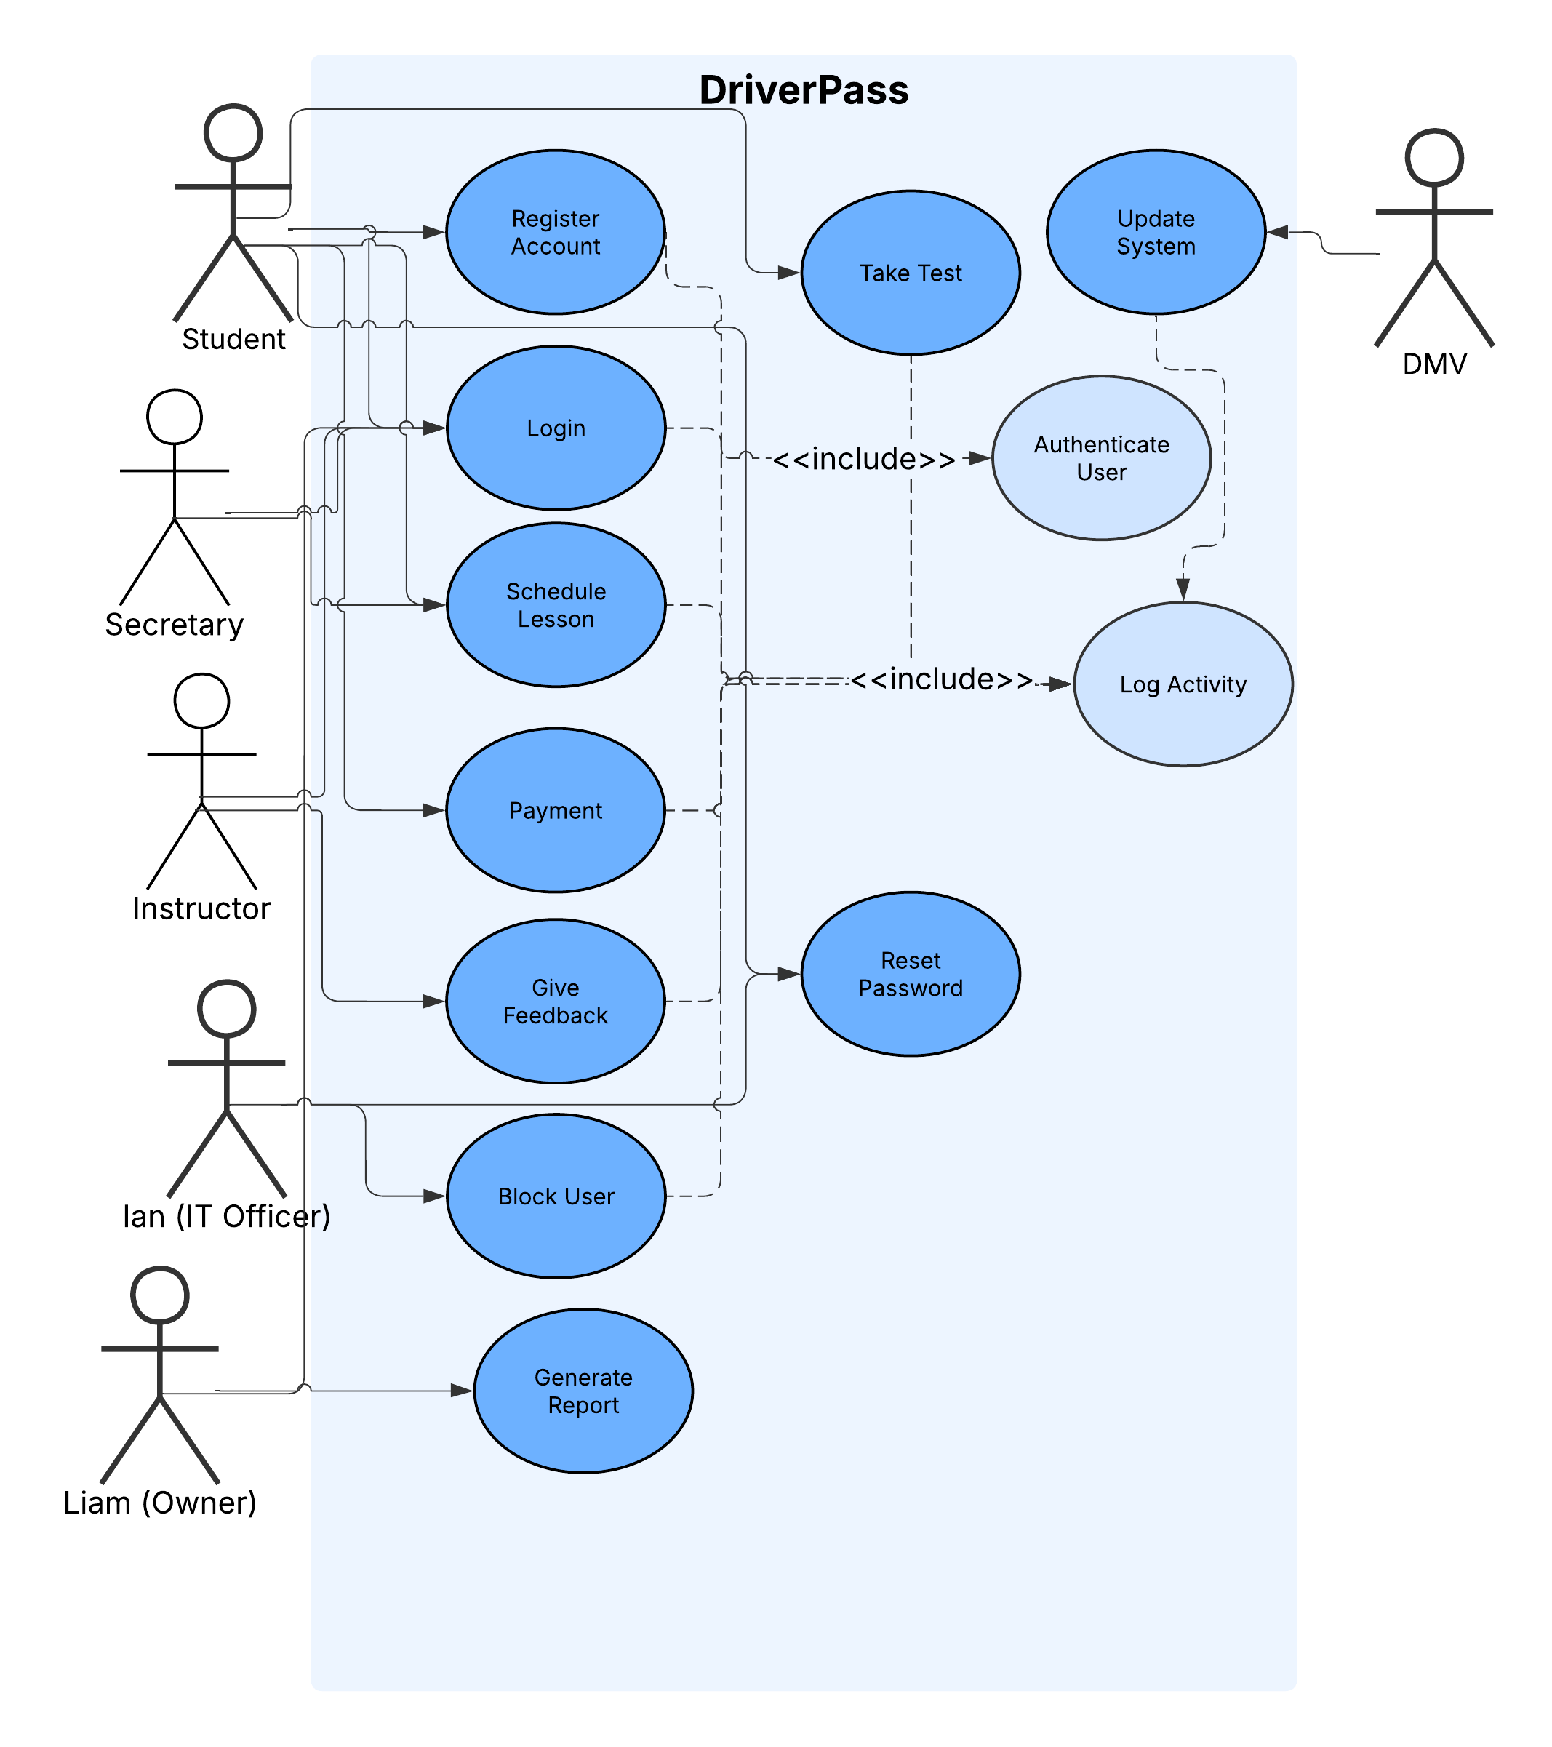

UML Activity Diagrams
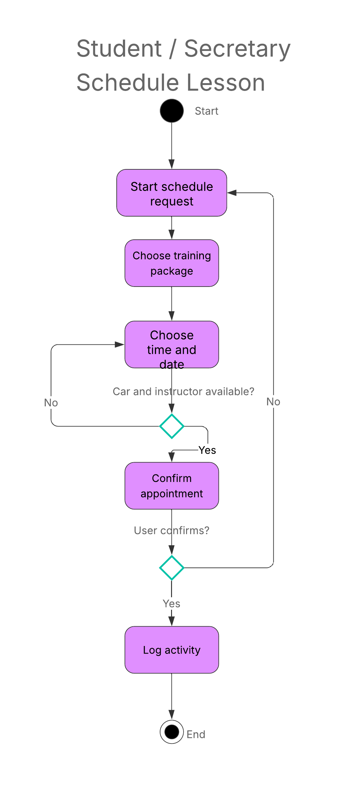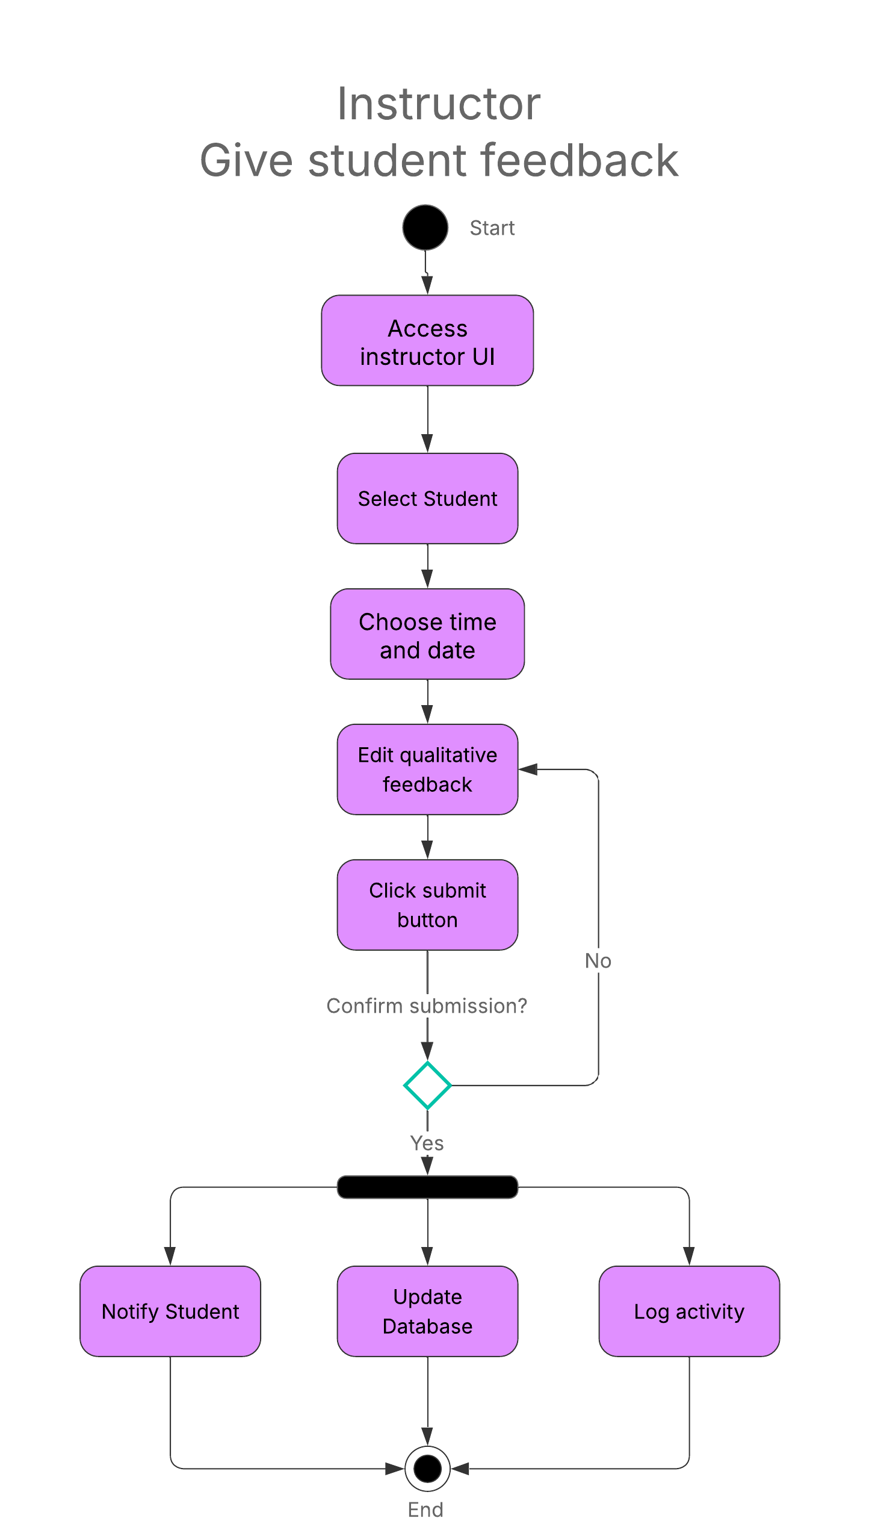

UML Sequence Diagram
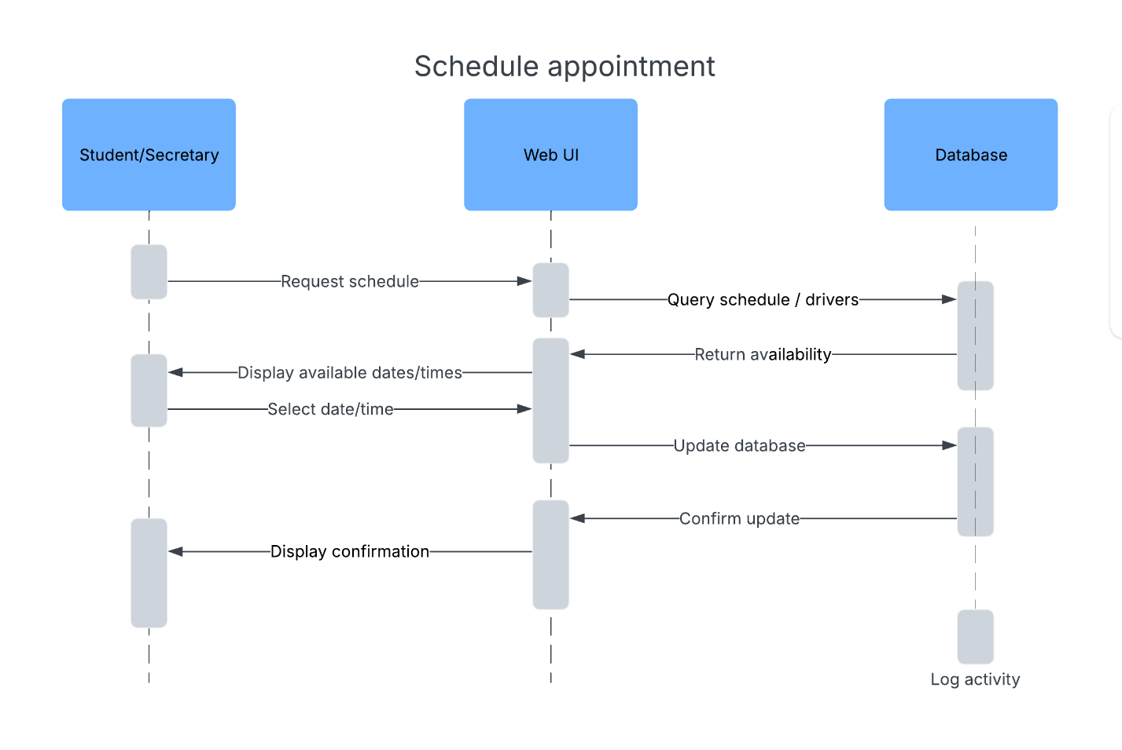

UML Class Diagram
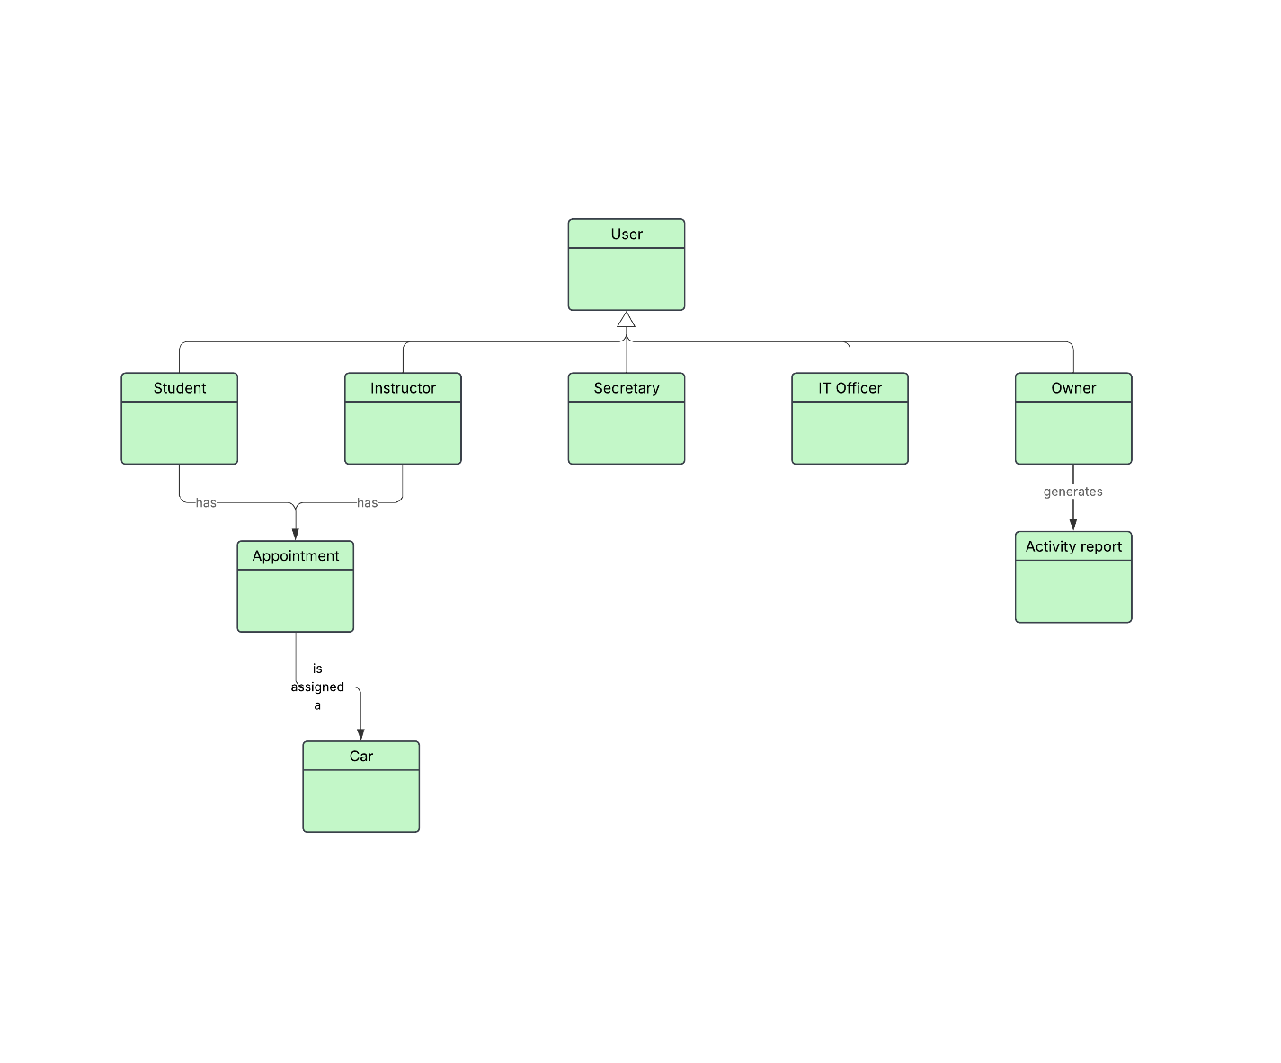

Technical Requirements

The technical requirements include a cloud system on which the whole service will be hosted. The cloud provider will handle all security and technical upkeep, as well as automated backups of the whole system, per Ian’s requirement to have minimal technical issues, leaving our developers to focus on the product itself. The driverpass system will use a relational database such as MySQL to manage data for students, instructors, schedules, and more. The use of the database will prevent data redundancy per the project requirements. The web-based GUI will allow all users to login and present them with a distinct portal or dashboard based on their role, giving them access to the features available to that role. Students will be able to register accounts in the system by themselves in a self-service web GUI. The secretary role will be able to create and modify appointments for lessons on behalf of students. The IT Officer may manage all users in the system. Liam, the owner, will be able to generate activity reports and export data for offline analysis in Excel. The system will send notifications to students for things like DMV updates, password resets, and appointments. There will be a connection with the DMV that will allow for automatic updates of information regarding law changes and practice questions.

